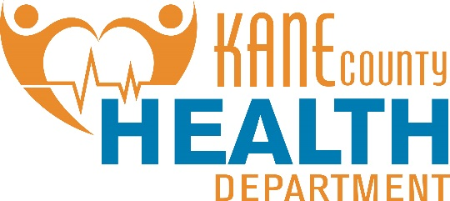

August 19, 2019  
Contact: Susan Stack 630-444-3098  
KaneHealth.com

**Kane County Health Department Seeks Proposals for Teen Advisory Panel on Tobacco**

Kane County Health Department is seeking proposals for a Teen Advisory Panel (TAP) for the tobacco REALITY program. One $5,000.00 grant award is available during the period of October 1, 2019 to June 30, 2020. RFP responses are due no later than 3PM, Monday, September 16, 2019.

REALITY Illinois is an in-your-face, stand-up-and-shout, not-taking-it-anymore anti-tobacco movement created by and for Illinois teens. Funded by the Illinois Department of Public Health and local health departments, REALITY Illinois is spreading the word about tobacco industry manipulation, second-hand smoke and tobacco use to everyone in the state.

Engaging Youth for Positive Change is a transformative process empowering young people to work with local governing bodies to adopt policies that create healthier communities. Targeted to youth ages 13-18, trained facilitators guide youth to identify the change they desire, learn about the workings of local governing bodies, engage friends, neighbors, and business leaders in their efforts, and communicate with elected officials to create change.

(more)

**Kane County Health Department Seeks Proposals for Teen Advisory Panel on Tobacco – page 2**

The REALITY Illinois program integrates youth as actively engaged participants in tobacco control policy development and adoption. Involvement of well-prepared youth can lead to important policy and social norm changes. REALITY Illinois Teens seeks to directly impact tobacco control policies by working locally on issues such as reducing exposure to second-hand smoke and protecting the environment from tobacco litter.

To learn about past teen groups, get more information about REALITY Illinois and to download the TAP application, visit http://kanehealth.com/Pages/Tobacco-Prevention.aspx

# # #